|  |  |
| --- | --- |
| The battle of neighbourhood  FINDING BEST LOCATION TO OPEN A NEW INDIAN RESTURANT IN LONDON,UK. | IBM DATA SCIENCE PROFESSIONAL SPECIALIZATION BY COURSERA  By - Kishan Kumar |

|  |  |  |
| --- | --- | --- |
| 1 | INTRODUCTION | 3 |
| 2 | BUSINESS PROBLEM | 3 |
| 3 | DATA | 3 |
| 4 | METHODOLOGY | 6 |
| 5 | RESULT AND DISCUSSION | 10 |
| 6 | CONCLUSION | 11 |

TABLE OF CONTENTS

1. **INTRODUCTION :-**

London is one among the cities in the world, where a large Indian Population resides.It is referred to as the Arch of the world because of its role as the once world’s most powerful kingdom.It has a population of over ten million, making it a megacity and most populous city in United Kingdom. Being a demographically diverse city, the needs of the residents are also increasing rapidly. Hence, any new organization or an existing one should keep up with their pace in supplying the needs of the customers.

1. **BUSINESS PROBLEM :-**

Our customer is ABC Restaurant, which is an International Indian Restaurant Brand and also a market leader. ABC Restaurant has recently planned to expand its business to the United Kingdom, and they want to start this journey from the heart of the UK itself. Given the extremely large size and the population of the city, our customer wants to identify the best neighbourhood area to open its first Indian Restaurant covering the majority of the population and facing least competition from other restaurants. The problem statement will be: Which neighbourhood has most Indian population and has lesser number of INDIAN RESTAUARNT’s?

1. **DATA :-**

The data to be used in this project is not readily available. Hence, the data has been obtained from various sources such as:-

* **Foursquare,** which is a local search-and-discovery mobile and web based app which provides search results for its users.
* **Wikipedia**, which has the details about the neighborhoods in LONDON. <https://en.wikipedia.org/wiki/List_of_areas_of_London>
* The geographic coordinates of each location have been obtained through Geopy(<https://geopy.readthedocs.io/en/stable/>)
* The Indian population in LONDON has been obtained from : <https://en.wikipedia.org/wiki/Indian_community_of_London>
  1. **DATA DESCRIPTION**

In this project, London will be used as synonymous to the "Greater London Area". Within the Greater London Area, there are areas that are within the London Area Postcode. The focus of this project will be the nieghbourhoods are that are within the London Post Code area.

The London Area consists of 32 Boroughs and the "City of London". Our data will be from the link - Greater London Area [List of areas of London](https://en.wikipedia.org/wiki/List_of_areas_of_London)

Raw dataframe looks like this—

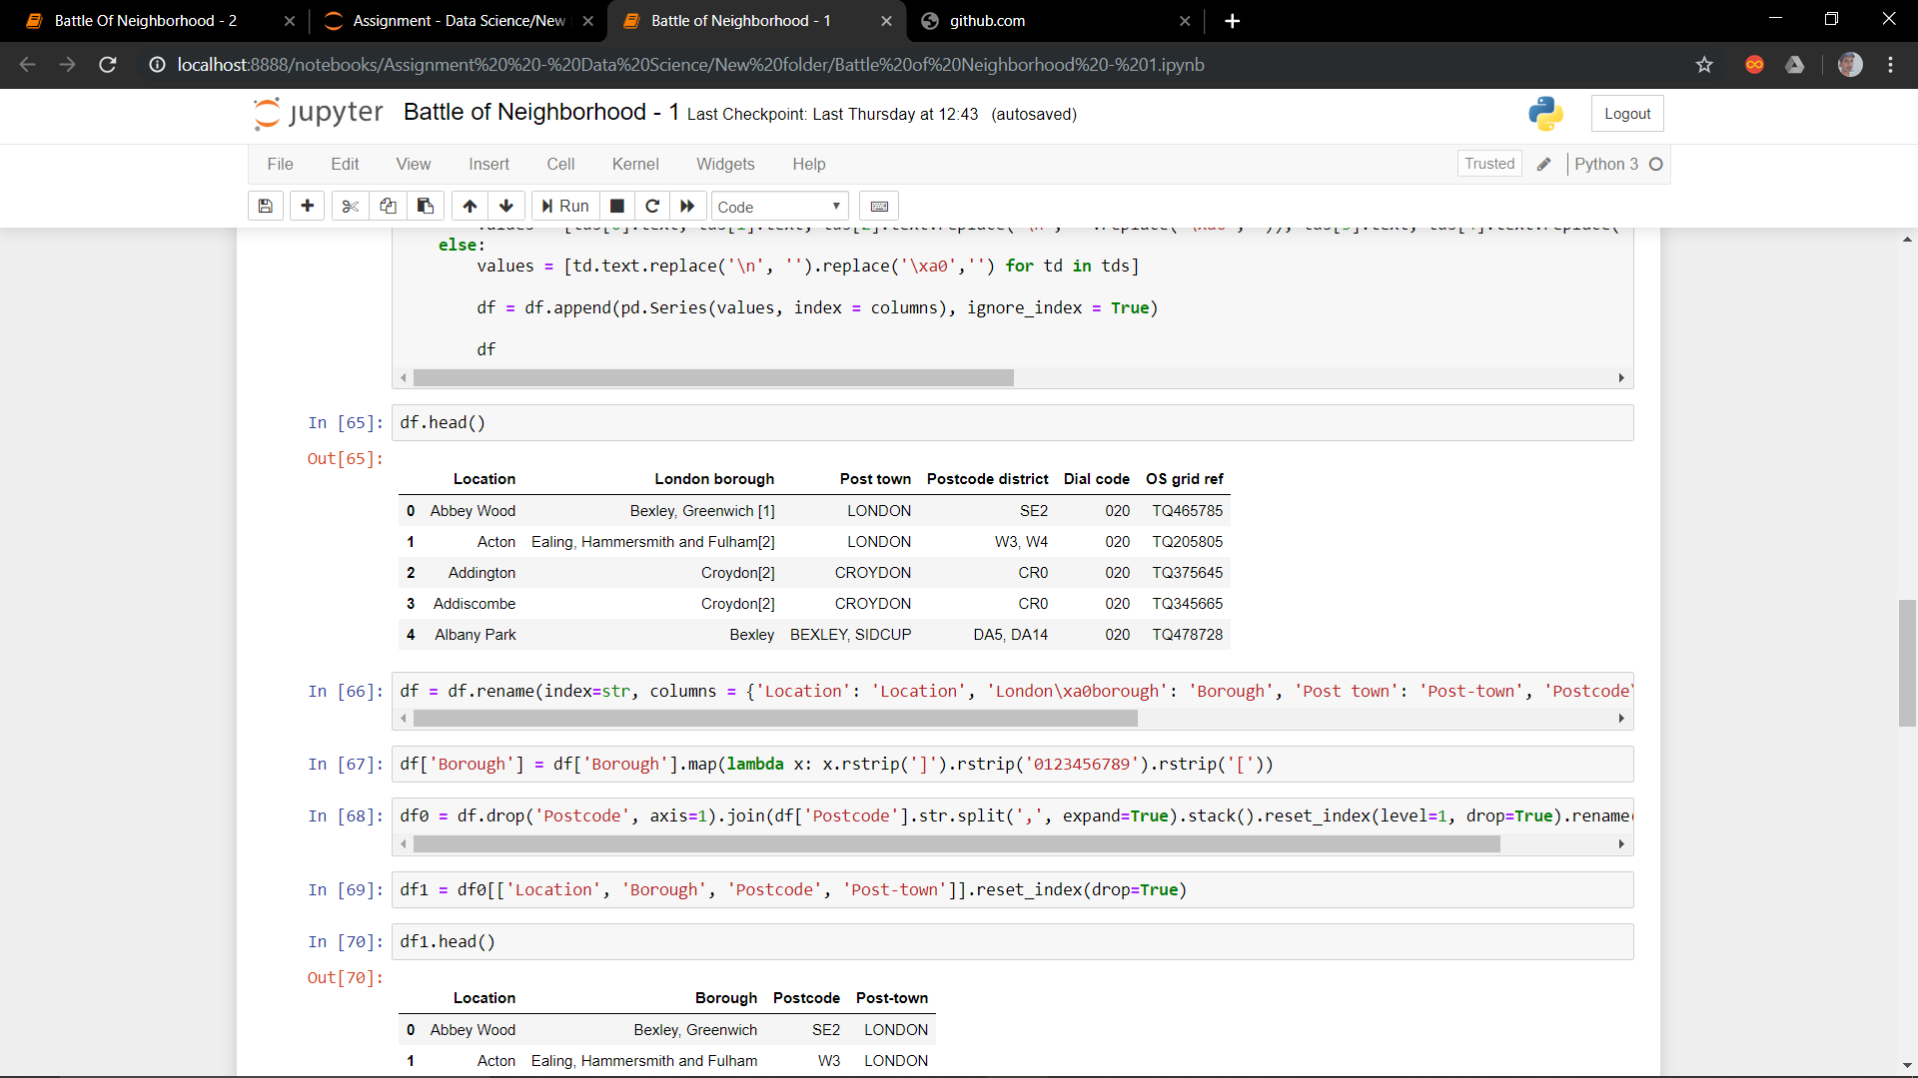

This raw dataframe is extracted from Wikipedia page containing borough of London.

Our Dataframe containing Location’s Longitude and Latitude is –

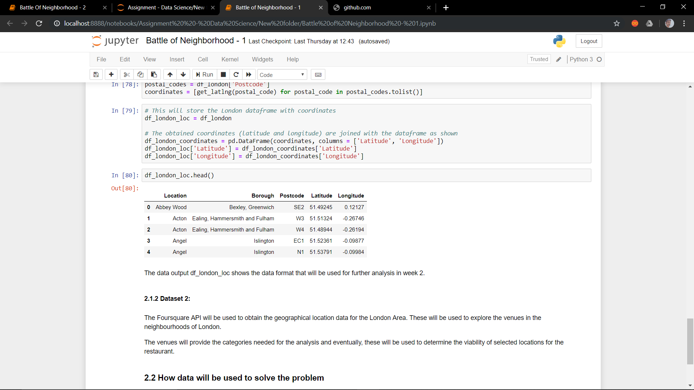

**METHODOLOGY -**

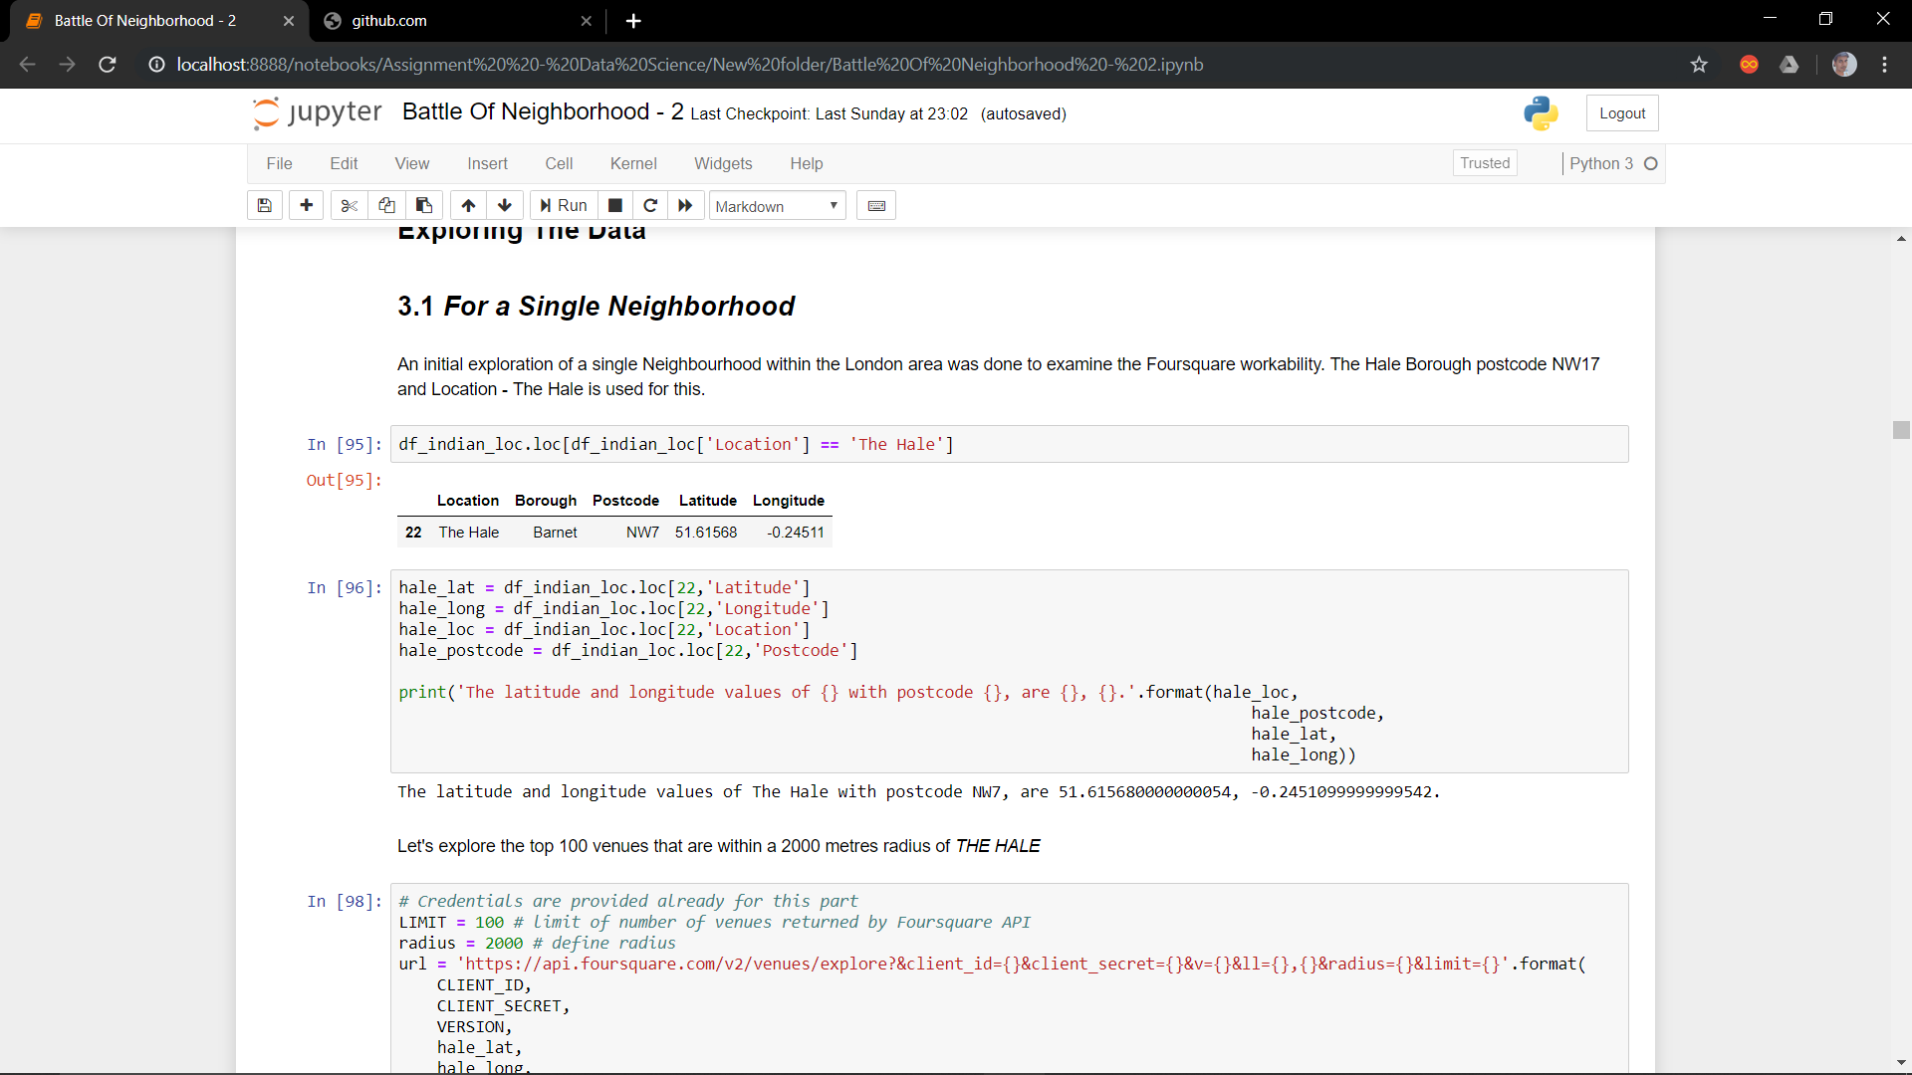

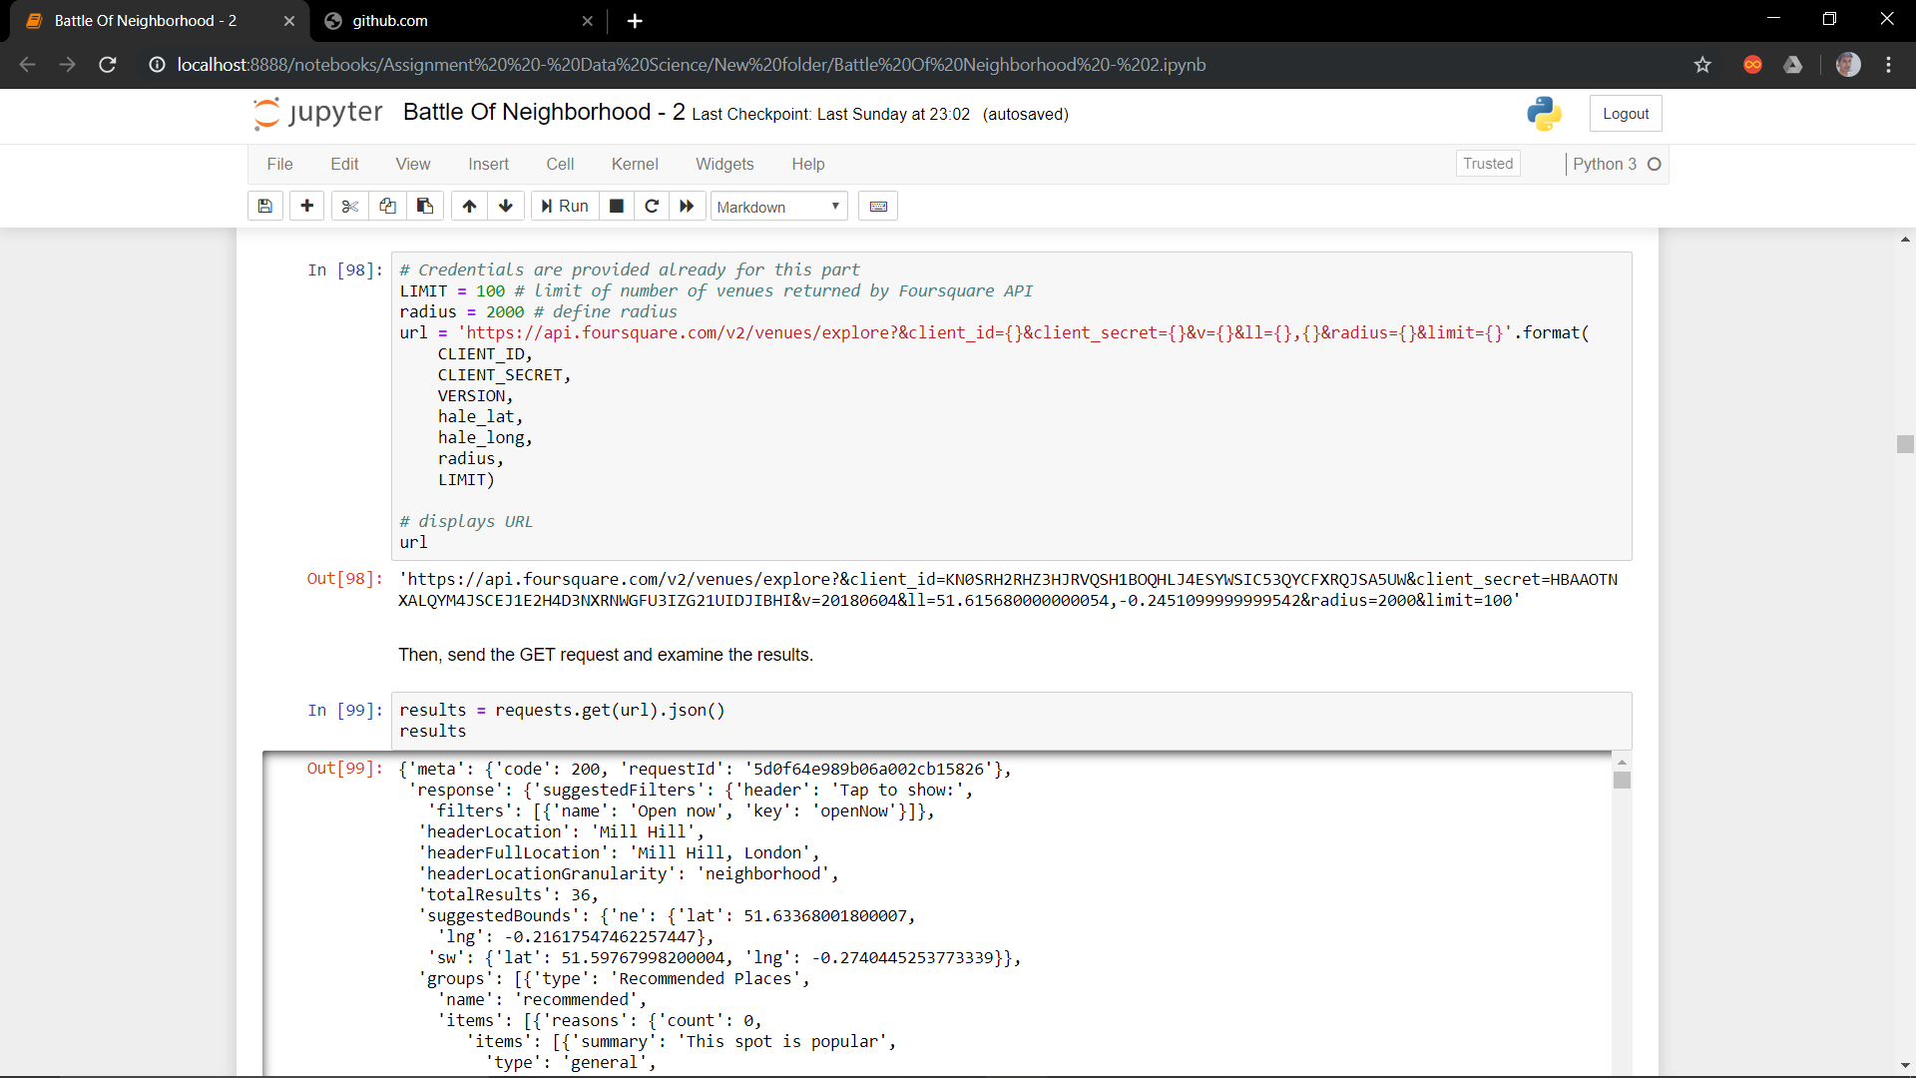

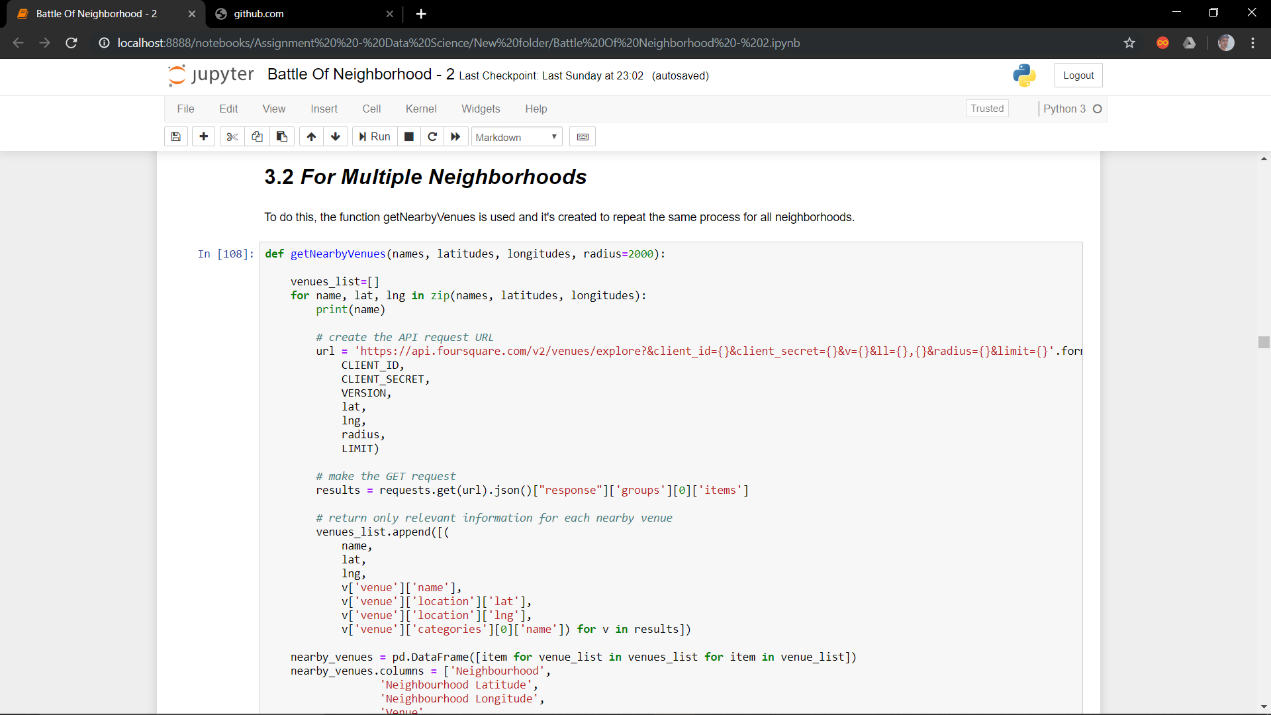

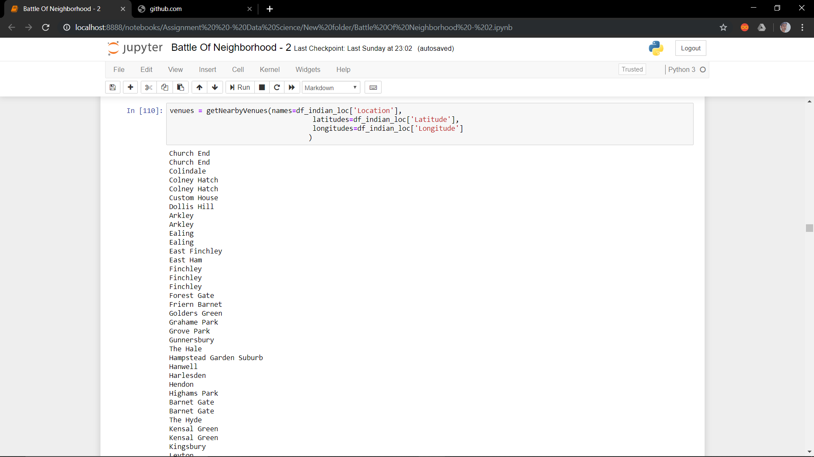

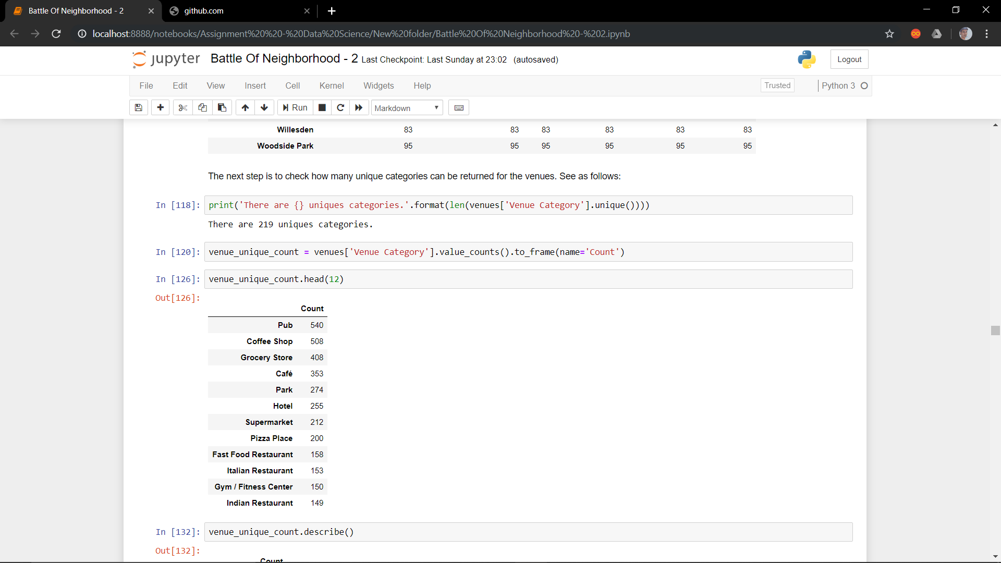

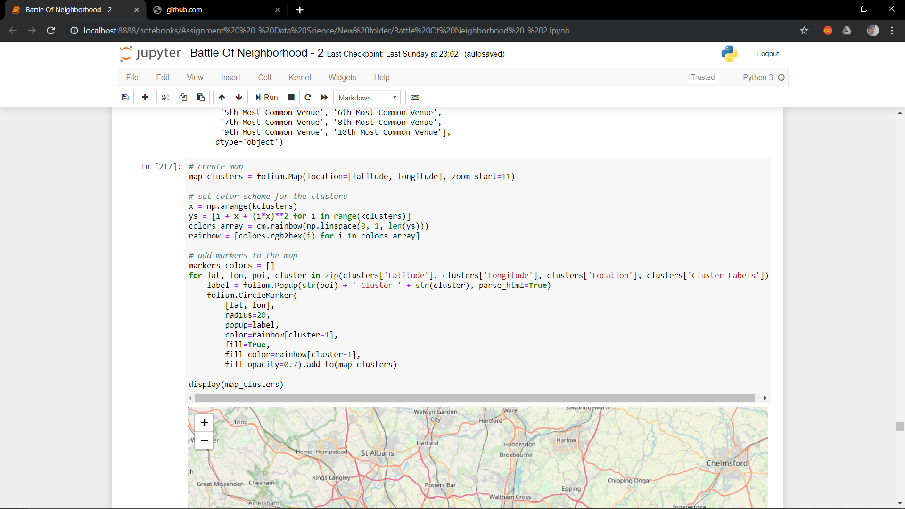

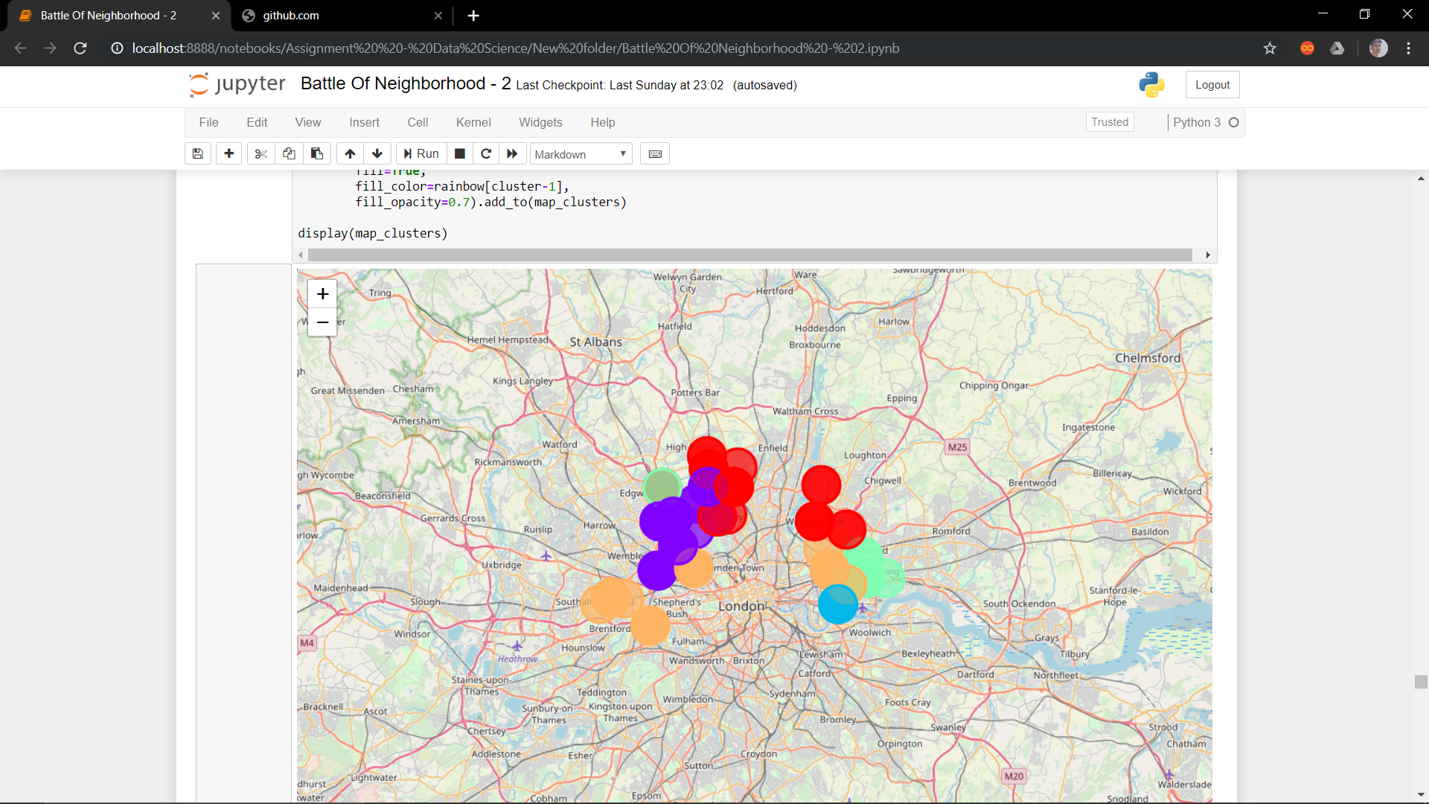

**RESULT**

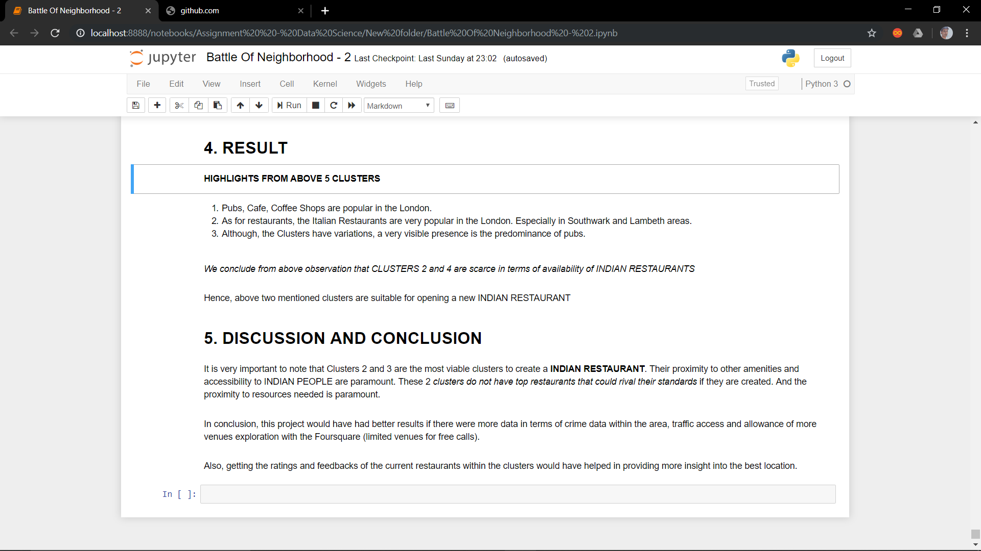

**CONCLUSION –**

